**DAILY ONLINE ACTIVITIES SUMMARY**

|  |  |  |  |  |  |  |  |  |
| --- | --- | --- | --- | --- | --- | --- | --- | --- |
| **Date:** | **1-06-2020** | | | | | **Name:** | **Dhanya Bhat** | |
| **Sem & Sec** | **7 B sec** | | | | | **USN:** | **4AL16CS132** | |
| **Online Test Summary** | | | | | | | | |
| **Subject** | | **System modelling and simulation(sms)** | | | | | | |
| **Max. Marks** | | **60** | | **Score** | | | **60** | |
| **Certification Course Summary** | | | | | | | | |
| **Course** | **Introduction to ethical hacking completed**  **RPA certification course** | | | | | | | |
| **Certificate Provider** | | | **Udemy** | | **Duration** | | | **6+3hrs** |
| **Coding Challenges** | | | | | | | | |
| **Problem Statement**: 1. Write a Java Program to left rotate the elements of an array.  **2.** Python Program to remove duplicate elements from a list.  **3.** Given an array of positive integers. Write a C Program to find the leaders in the array. | | | | | | | | |
| **Status: YES, Completed all Programs.** | | | | | | | | |
| **Uploaded the report in Github** | | | | | **YES** | | | |
| **If yes Repository name** | | | | | <https://github.com/Goutham-dotcom/JavaharGoutham> | | | |

Online Test Details: (Attach the snapshot and briefly write the report for the same)

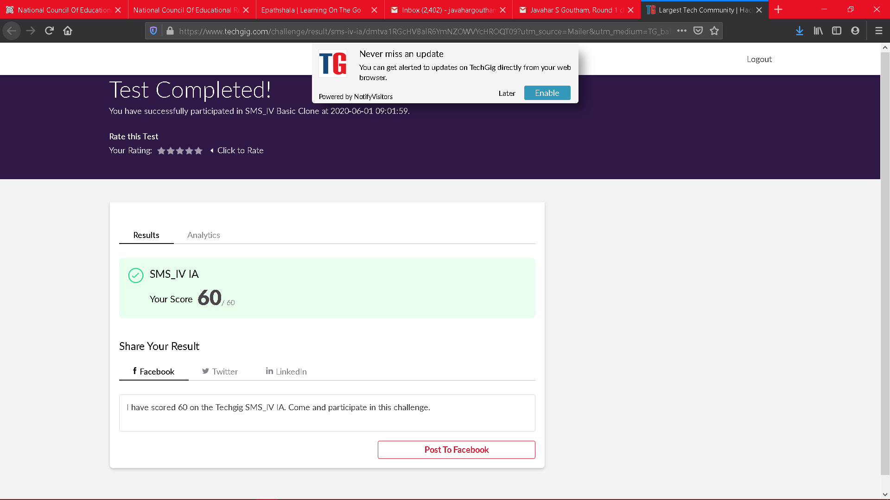

Scored 60 out of 60 in SMS I.A test

Certification Course Details: (Attach the snapshot and briefly write the report for the same)

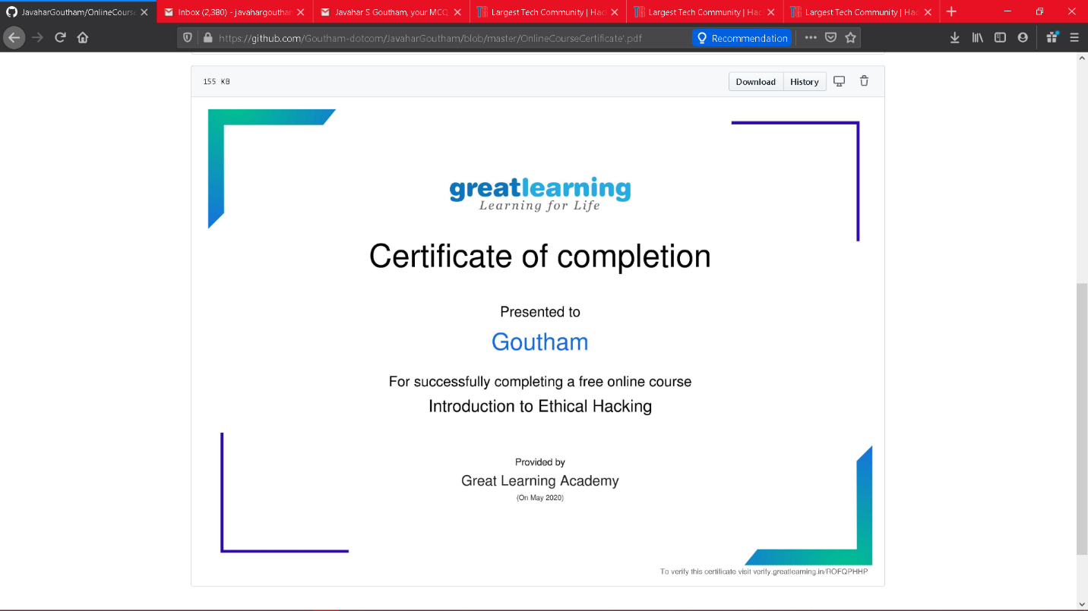

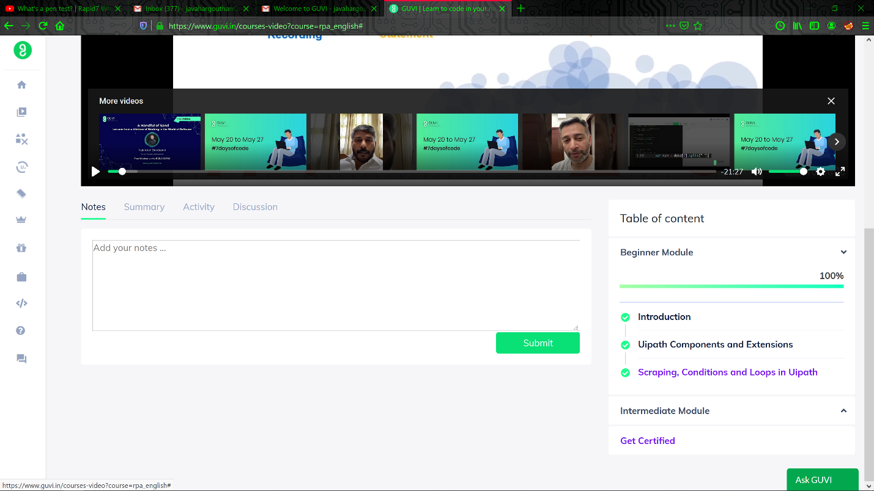

.

Coding Challenges Details: (Attach the snapshot and briefly write the report for the same)

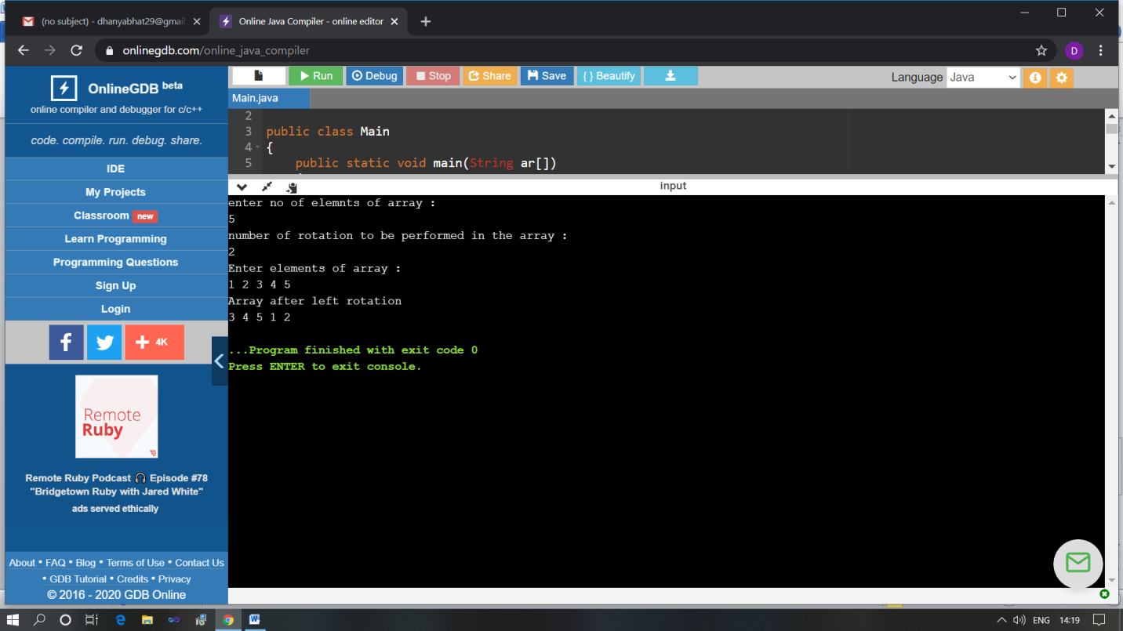

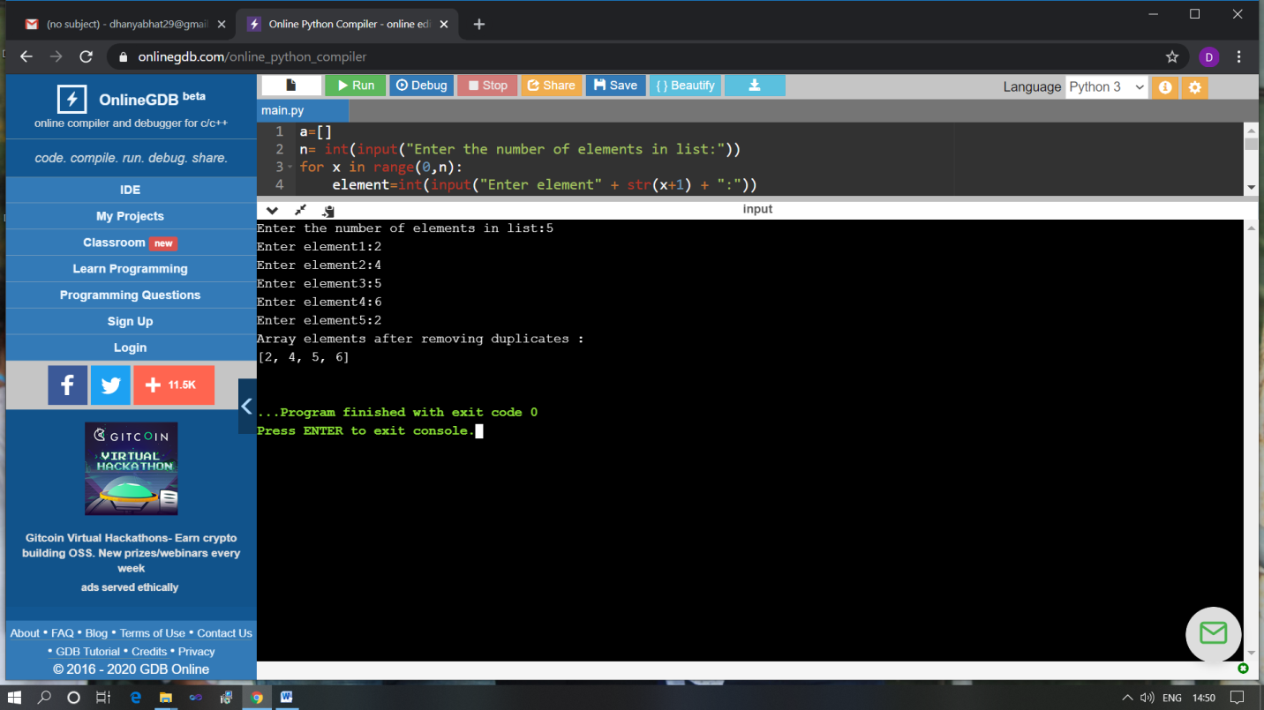

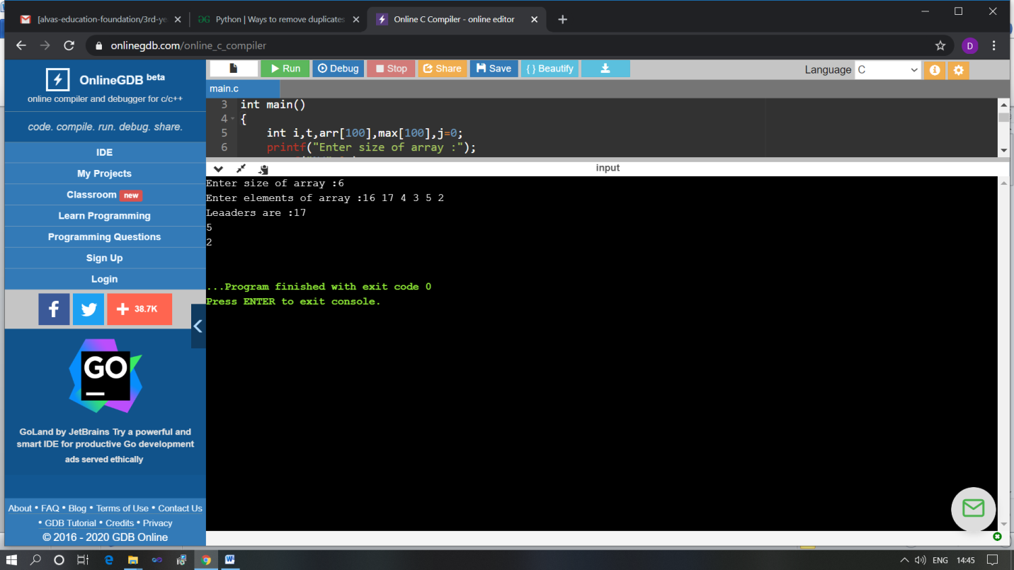

The above Programs were written and executed and the output of the same is displayed above. The code for those 3 programs have been uploaded to the github repository and the link to the same is provided on the form.